REGEX ONLINE TRAINING PYTHON ASSIGNMENTS

Class 2:

Answer 1:

Output of (3+4\*\*6-9\*10/2) will be: 4054

Answer 2: To count vowels in a string (“HELLO THIS SIDE REGEX”)

PROGRAM:

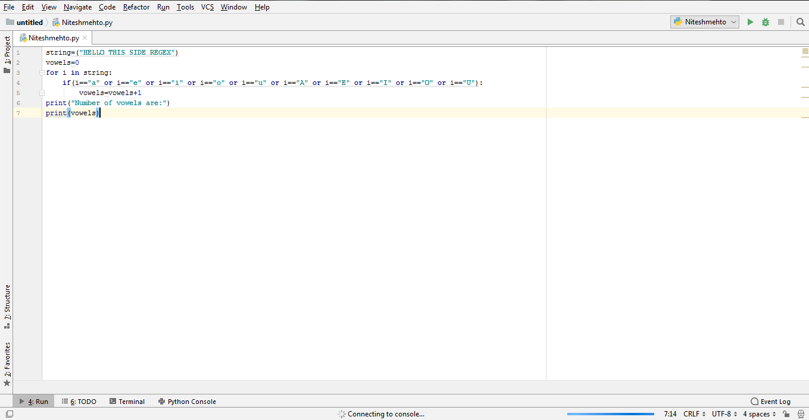

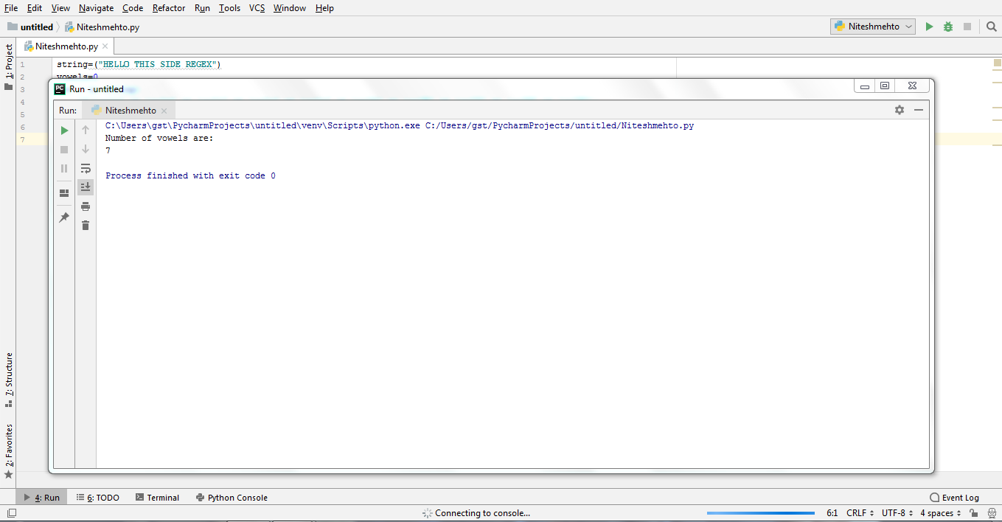

Answer 3:

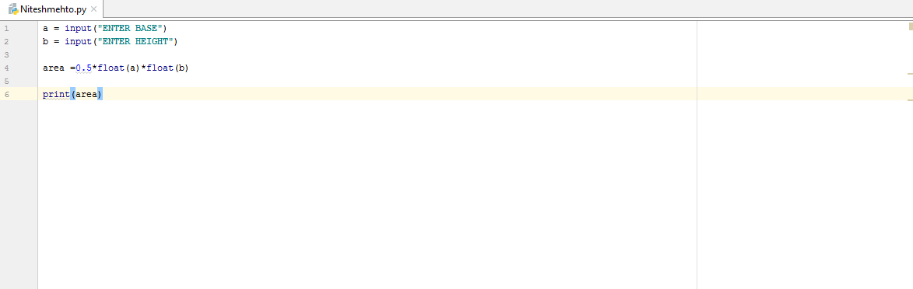

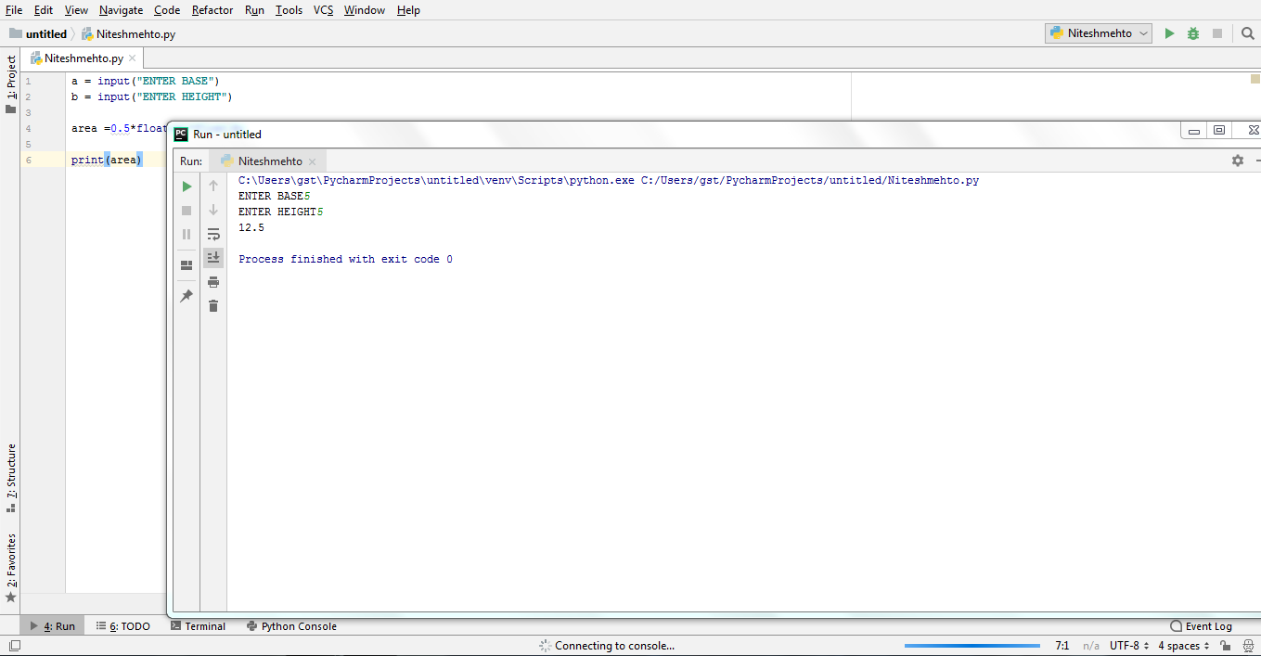

Class 3:

Answer 1:

ARMSTRONG NUMBER PROGRAM

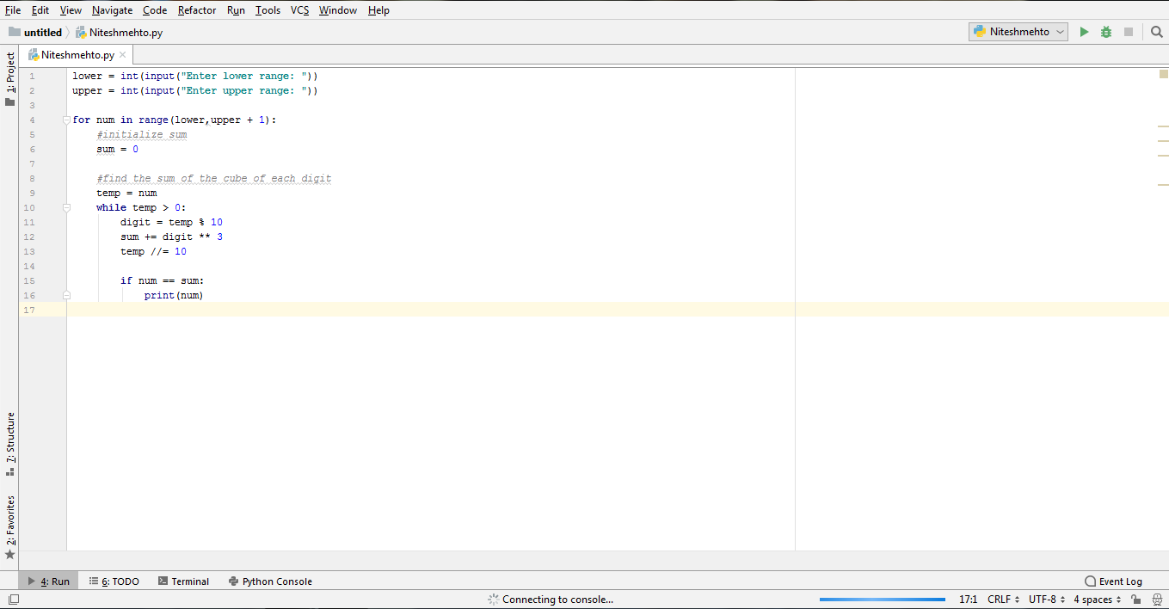

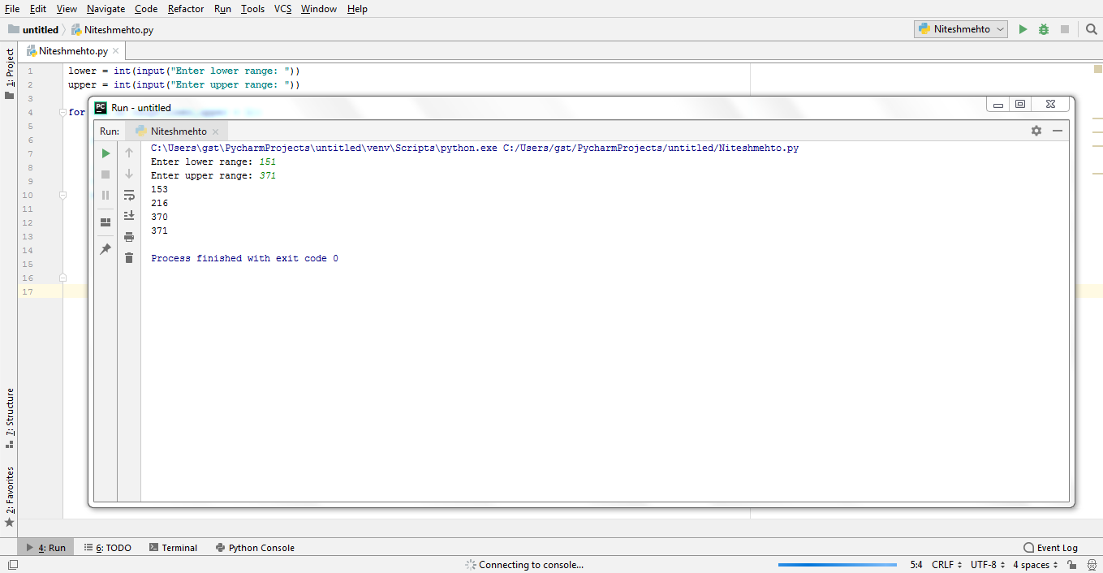

Answer 2:

REMOVE PUNCTUATIONS FROM STRING:

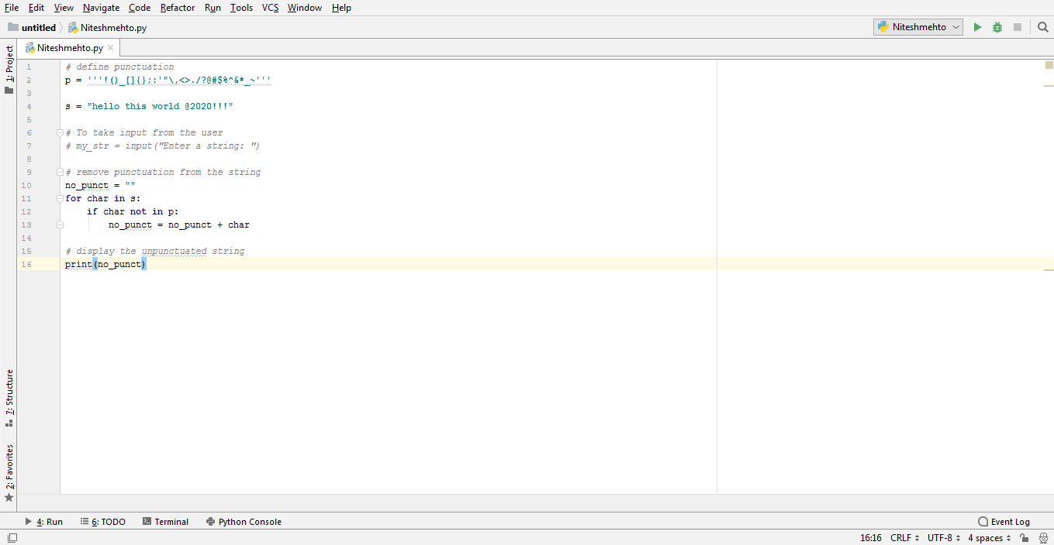

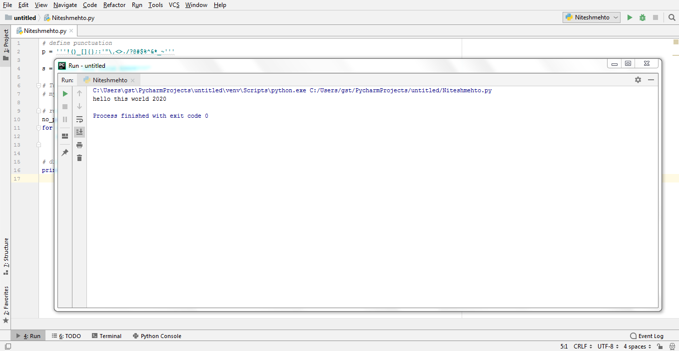

Answer 3:

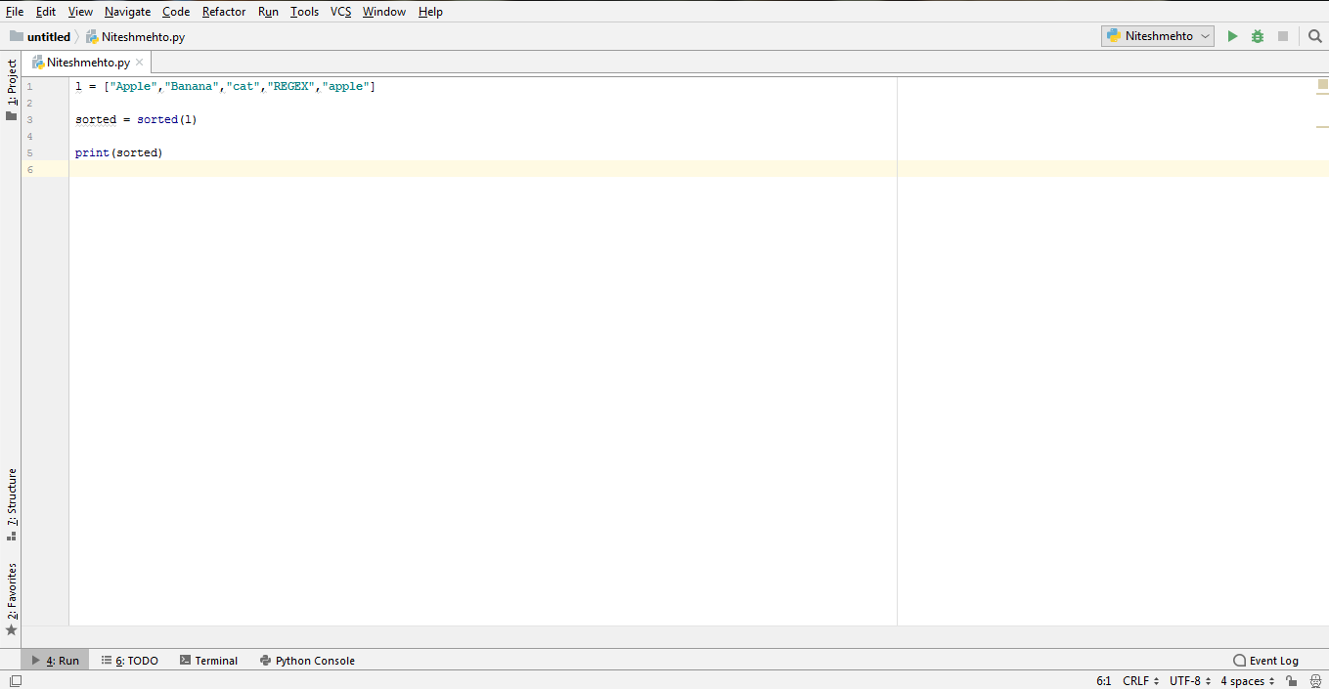

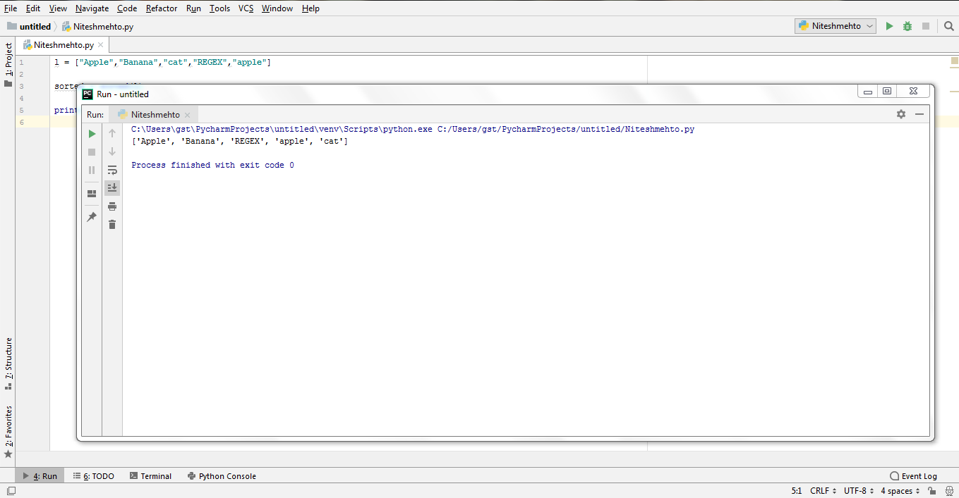

SORTING WORKS FIRSTLY ON ALL UPPERCASE STARTING ALPHABETS AND THEN ON THE LOWERCASE STARTING ALPHABETS